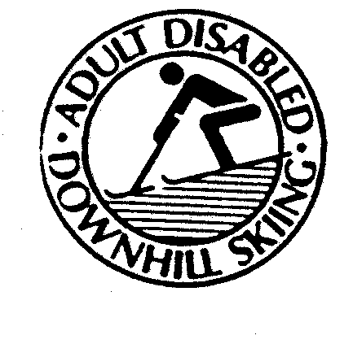
ADULT DISABLED DOWNHILL SKIING (ADDS)

MEMBERSHIP APPLICATION / RELEASE FORM

Please complete, print and sign.

I, ________________________________, confirm that I wish to participate as:
◻ a volunteer or
◻ participant skier
in the Adult Disabled Downhill Skiing Program (the “ADDS Program”).

I am a paid-up member for the 2015-16 season with CADS:
◻ Yes, & I’ve sent my confirmation to ADDS, OR ◻ attached is a copy of my confirmation
◻ No, but my $35 membership fee (cheque to “CADS Ontario”) and completed application form is attached

I understand that there are inherent risks involved in skiing and in other aspects of the ADDS Program, which risks may include physical injury to myself. In consideration of being allowed to participate in the ADDS Program as a volunteer or participant skier, I hereby release and discharge Mansfield Ski Resort; the Adult Disabled Downhill Skiing (ADDS) Program; the Canadian Association for Disabled Skiing (Ontario Division); the Canadian Association for Disabled Skiing and its Provincial Divisions; together with their respective officers, employees, agents, and volunteers, from any and all liability, claims, demands, actions or causes of action on account of any injury or damage whatsoever and howsoever caused including negligence, that I may suffer as a result of my participation in the ADDS Program.

I authorize the ADDS Program to use photographs or videos containing my image for promotional, advertising, fund-raising and/or public relations purposes. I acknowledge and confirm that all photographs, advertisements, Web site materials and related records and documents used in, arising out of or related to the ADDS Program’s promotional, advertising and/or public relations activities, shall remain the exclusive property of the ADDS Program, which shall own all copyright. I also waive any and all rights to any personality rights in such material.

Date: Signature of Applicant:
Date of Birth: (dd/mm/yyyy) Present age: yrs. Weight: lbs
Address:
Home or Office Tel #: Cell #:
Email address:
CADS certification level: None ◻ Level Year achieved
CSIA certification level: None ◻ Level Year achieved
Emergency Contact: Relationship: Tel:

In case of the Volunteer being a minor under age 18 years, signature of parent(s) or guardian(s) is required. By signing below, the parent(s) or guardian(s) agrees to the above statements on behalf of the minor, and grants permission for the minor to participate in the ADDS’ Program.

Name of Parent(s) or Guardian(s) (please print):
Signature of Parent(s) or Guardian(s):

Please Return to “ADDS Membership” c/o Brad Ko, a minimum of 1 week before your first planned ski day:

Via Email to: ski.adds@disabledskiingontario.com or brad.ko@gmail.com

